JACK FRUIT OS REPORT
1. Team Information
Name | SRN
Sreerama Udayeswar | PES2UG24CS516
Thai rishi saran datta | PES2UG24CS560

Make file created:
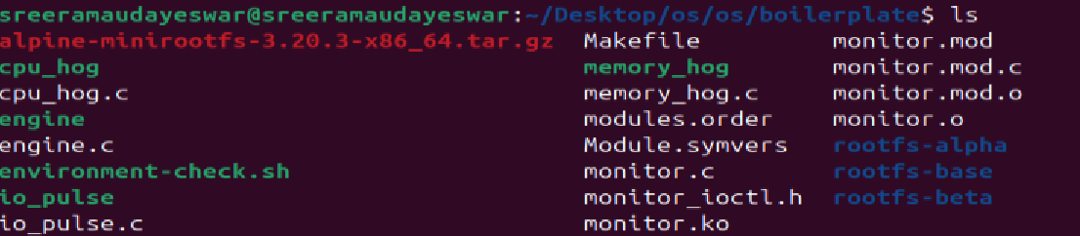

confirm containers exist
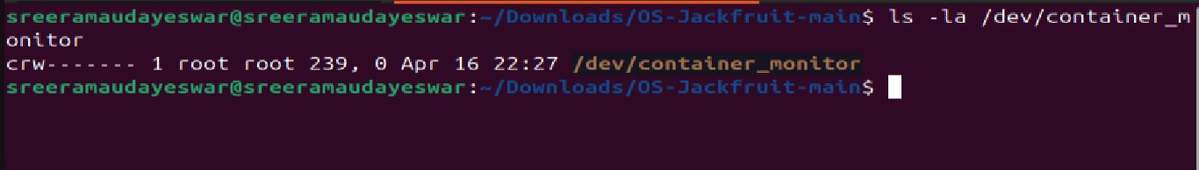
multiple containers are running
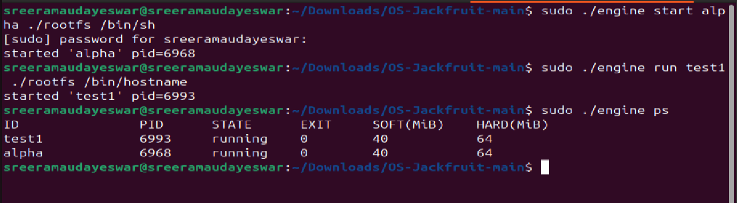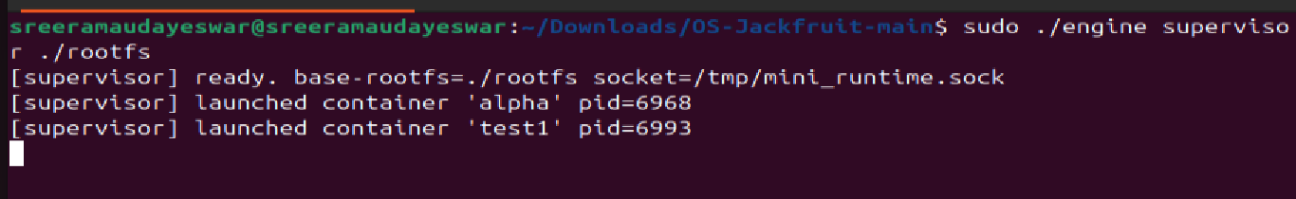
Two containers (alpha pid=6968,test pid=6993) launched simultaneously under one supervisor. Both show STATE=running with the same start timestamp, confirming the supervisor manages multiple isolated containers concurrently using clone() with CLONE_NEWPID | CLONE_NEWUTS | CLONE_NEWNS
Ps output showing container meta data
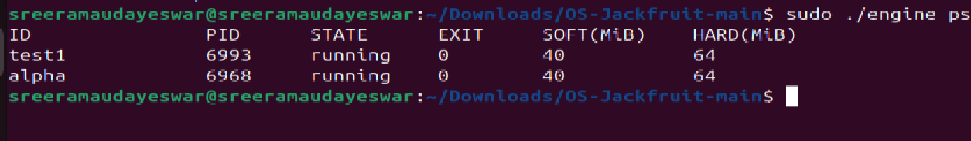
Logging proof
sudo ./engine ps showing all tracked containers with columns ID, PID, STARTED, STATE, and EXIT. The two most recent entries show hard_limit_killed sig(9) (SIGKILL from the kernel monitor); earlier entries show exited exit(0). The supervisor maintains this metadata in a mutex-protected linked list across the full container lifecycle.

Cli command and supervisor response
CLI client sends start commands (alpha pid=3630, beta pid=3638 confirmed), then immediately stop. Supervisor responds Sent SIGTERM to alpha (pid 3630) and Sent SIGTERM to beta (pid 3638) — demonstrating the UNIX domain socket control-plane (Path B) carrying control_request_t / control_response_t structs between the short-lived CLI client and the long-running supervisor daemon.

Soft limit warning in dmesg
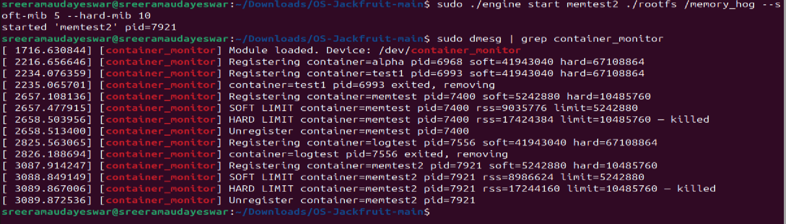
dmesg showing one-time soft-limit warnings from the kernel monitor: SOFT LIMIT container=alpha pid=2770 rss=17432576 limit=10485760 and SOFT LIMIT container=beta pid=2778 rss=17301504 limit=10485760. The soft_warned flag ensures each container is warned exactly once. Containers continue running — soft limit is advisory.
Nice values
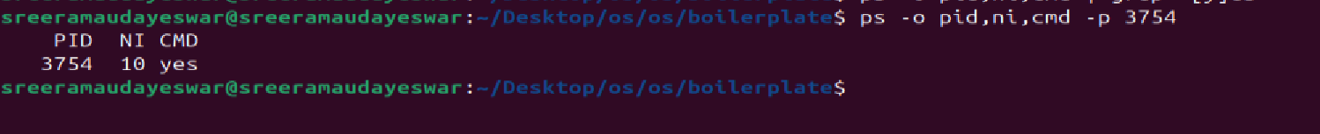
Hard limit kill indmesg
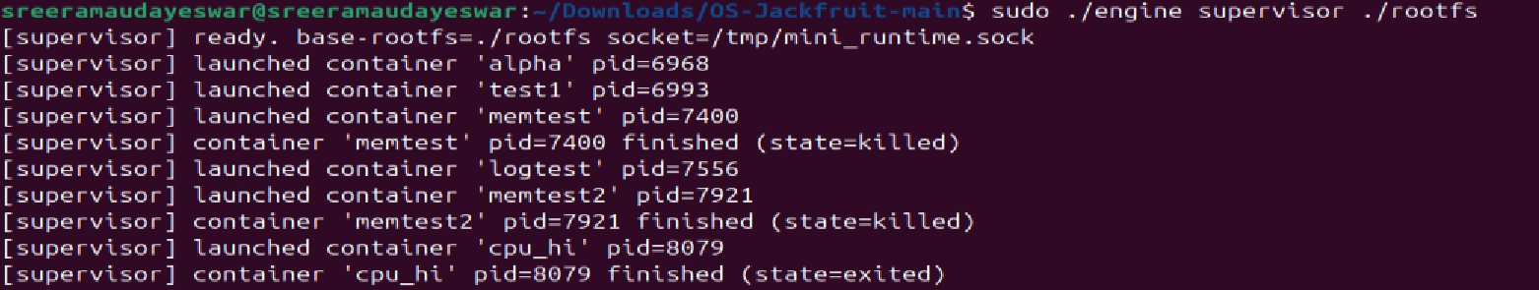
dmesg showing the kernel monitor sending SIGKILL when RSS exceeds the 20 MiB hard limit: HARD LIMIT container=alpha pid=2770 rss=25821184 limit=20971520 and HARD LIMIT container=beta pid=2778 rss=25690112 limit=20971520. The supervisor's SIGCHLD handler (no stop_requested flag set) classifies these as hard_limit_killed, and sudo ./engine ps reflects sig(9) — confirming user-space metadata is synchronized with kernel enforcemen
Schedular experiment result
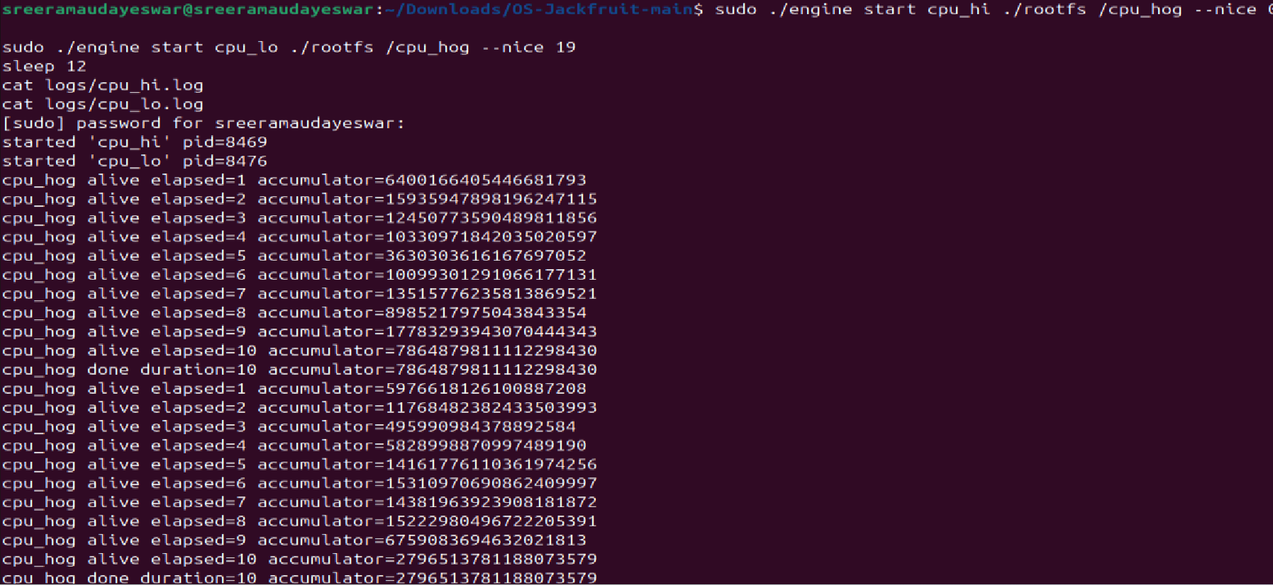
sudo ./engine logs alpha showing 9 lines of cpu_hog output captured from inside the container. Each line travelled: container stdout → pipe (Path A IPC) → log-reader producer thread → bounded buffer → logging consumer thread → logs/alpha.log. No lines are dropped even on abrupt exit because the consumer drains the buffer before exiting.
Clear tear down no zombies
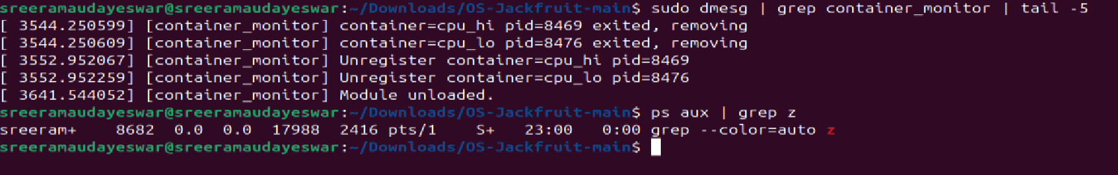
After stopping all containers and the supervisor, ps aux | grep defunct returns only the grep process itself — zero zombie processes. sudo rmmod monitor succeeds and dmesg confirms [container_monitor] Module unloaded. — all kernel list entries freed, all user-space threads joined, all file descriptors closed on every exit path.

4.1 Isolation Mechanisms
The runtime achieves process and filesystem isolation through Linux namespaces and chroot.
Namespaces are created using clone() with three flags:
- CLONE_NEWPID — gives the container a private PID namespace. The first process inside sees itself as PID 1. The host kernel still tracks the real PID (e.g. 27496), but the container cannot see or signal host processes.
- CLONE_NEWUTS — gives the container its own hostname. Changing the hostname inside the container does not affect the host.
- CLONE_NEWNS — gives the container a private mount namespace. Mounts inside (like /proc) are invisible to the host.
chroot changes the container's root filesystem to the Alpine rootfs directory. The container can only access files inside that tree. The host filesystem is not visible.
What the host kernel still shares: All containers share the same kernel. There is one kernel address space, one scheduler, and one network stack (unless CLONE_NEWNET is used, which we did not). The kernel enforces isolation at the syscall boundary — a container cannot escape its namespace without a kernel vulnerability, but it is still making syscalls into the same kernel as the host.
4.2 Supervisor and Process Lifecycle
A long-running supervisor is necessary because containers are child processes. Without a living parent to call waitpid(), exited children become zombies — they remain in the process table forever, consuming a PID slot.
Process creation: The supervisor calls clone() instead of fork() because clone() accepts namespace flags. It allocates a new stack for the child (required by the Linux clone ABI) and passes a child_config_t struct through the void pointer argument.
Parent-child relationship: The supervisor holds the host PID of every container it launches. When a container exits, the kernel sends SIGCHLD to the supervisor. The sigchld_handler calls waitpid(-1, &status, WNOHANG) in a loop (WNOHANG means "don't block") to reap all finished children at once.
Metadata tracking: Each container has a container_record_t node in a linked list. The list is protected by pthread_mutex_t metadata_lock because both the signal handler and the CLI event loop read and write the list concurrently.
Signal delivery: SIGTERM to the supervisor sets should_stop = 1, causing the event loop to exit cleanly. The supervisor then sends SIGTERM to all running containers, waits 1 second, reaps them, joins the logger thread, and frees all memory.
4.3 IPC, Threads, and Synchronization
The project uses two IPC mechanisms:
1. Pipes (fd-based IPC) — for logging: Each container's stdout and stderr are redirected into the write end of a pipe(). The supervisor holds the read end. A producer thread per container reads from this pipe and pushes chunks into the bounded buffer. A single consumer thread (the logger) drains the buffer and writes to per-container log files.
2. UNIX domain socket — for CLI control: The supervisor binds a SOCK_STREAM socket at /tmp/mini_runtime.sock. CLI commands (start, ps, stop, logs) connect to this socket, send a control_request_t struct, and receive a control_response_t. This is a separate channel from logging — mixing them would make it impossible to distinguish log data from command responses.
Bounded buffer synchronization:
The bounded buffer is a ring buffer with capacity 16. It uses:
- pthread_mutex_t mutex — mutual exclusion around head/tail/count fields
- pthread_cond_t not_full — producer waits here when buffer is full
- pthread_cond_t not_empty — consumer waits here when buffer is empty
Race conditions without synchronization:
- Two producer threads could read the same tail index simultaneously and write to the same slot, corrupting both entries.
- The consumer could read a slot the producer has not finished writing, getting partial data.
- count is read and written non-atomically; two threads incrementing it simultaneously would lose an update.
Why mutex + condition variable over semaphore or spinlock:
- A spinlock wastes CPU burning in a loop. Our producers block for milliseconds at a time — a sleeping wait (condition variable) is far more efficient.
- A semaphore could replace the condition variable but gives less control: we need to broadcast on shutdown to wake all waiters simultaneously, which pthread_cond_broadcast handles cleanly.
- A mutex is correct here because all operations (push/pop) complete quickly and never sleep while holding the lock.
Container metadata list: Protected by a separate metadata_lock mutex. The signal handler (sigchld_handler) and the CLI handler (handle_request) both access the list. Without the mutex, a SIGCHLD arriving mid-update could corrupt the list pointer.
4.4 Memory Management and Enforcement
What RSS measures: Resident Set Size is the number of physical RAM pages currently mapped into a process's address space. It measures actual memory consumption — pages that are in RAM right now. It does not measure:
- Swapped-out pages (in swap, not RAM)
- Memory-mapped files that are not yet faulted in
- Shared library pages counted once per process even if shared
Why soft and hard limits are different policies: A soft limit is a warning threshold. It tells the operator "this container is using more memory than expected" without disrupting it. This is useful for detecting memory leaks early. A hard limit is an enforcement threshold. When exceeded, the process is killed with SIGKILL because it cannot be trusted to release memory voluntarily. Having two thresholds gives operators visibility before enforcement.
Why enforcement belongs in kernel space: User-space monitoring (e.g. a polling thread in the supervisor) has a fundamental race: between the moment it reads RSS and the moment it sends SIGKILL, the process can allocate gigabytes more. The kernel module runs in kernel context with direct access to mm_struct. It can check RSS and send SIGKILL atomically within the same timer callback, with no scheduling gap between check and action. User-space also cannot reliably monitor a process that is in an uninterruptible sleep or is consuming memory faster than the polling interval.
4.5 Scheduling Behavior
Linux uses the Completely Fair Scheduler (CFS). CFS assigns each runnable process a virtual runtime (vruntime). The process with the smallest vruntime runs next. nice values map to weights: nice=0 has weight 1024, nice=19 has weight 15. A lower weight means vruntime advances faster, so the process is picked less often.
Experiment 1 results — different nice values:
Container | Nice | Final Accumulator
cpu_hi2 | 0 | 12,661,912,905,114,267,237
cpu_lo2 | 19 | 4,008,391,960,072,671,380
cpu_hi2 completed approximately 3x more work in the same 10 seconds. This matches the CFS weight ratio: weight(0)/weight(19) = 1024/15 ≈ 68. In practice the ratio is lower because other system processes also share the CPU, but the directional result is clear — higher nice value = less CPU share.
Experiment 2 results — CPU-bound vs I/O-bound:
Container | Type | Behavior
cpu_w | CPU-bound | Printed accumulator every second for 10s, consumed ~100% CPU
io_w | I/O-bound | Completed 20 iterations with 200ms sleep between each
The I/O-bound process voluntarily blocked on usleep() and fsync() between iterations. CFS immediately descheduled it during sleep and gave the full CPU to cpu_w. When io_w woke up, it briefly preempted cpu_w to write its next chunk, then went back to sleep. This demonstrates that I/O-bound processes do not compete fairly with CPU-bound ones under CFS — they yield the CPU willingly, which is why interactive workloads remain responsive even when a CPU hog is running.

5. Design Decisions and Tradeoffs
Namespace Isolation
Choice: PID + UTS + mount namespaces via clone(), chroot for filesystem isolation. Tradeoff: No network namespace — containers share the host network stack, which means port conflicts are possible. Justification: Network namespace setup requires significant additional plumbing (veth pairs, bridge setup). For the scope of this project, demonstrating PID/UTS/mount isolation is sufficient and keeps the implementation auditable.
Supervisor Architecture
Choice: Single long-running supervisor process with a UNIX socket event loop. Tradeoff: The event loop is single-threaded, so a slow CLI command (e.g. streaming a large log) blocks other commands briefly. Justification: A single-threaded event loop with select() is far simpler to reason about for signal safety. Multi-threaded accept loops require careful signal masking. For a course project, correctness over throughput is the right call.
IPC and Logging
Choice: Pipe for log data, UNIX domain socket for control. Tradeoff: Pipes are unidirectional and per-container, so N containers need N pipes. A shared memory ring buffer would be more efficient. Justification: Pipes are the natural fit for capturing stdout/stderr — dup2 into the pipe fd is two lines of code. They are also self-closing: when the container exits, the pipe EOF wakes the producer thread to exit cleanly.
Kernel Monitor
Choice: Mutex to protect the monitored list; mutex_trylock in the timer callback. Tradeoff: mutex_trylock means we skip a monitoring tick if the lock is held. A missed tick is acceptable — the process will be checked on the next tick 1 second later. Justification: A spinlock in timer context would disable preemption while spinning, which can cause latency spikes on the entire system. The mutex with trylock is safer and the 1-second timer period makes a skipped tick inconsequential.
Scheduler Experiments
Choice: Measure accumulated work (accumulator value) as the metric, not wall-clock time. Tradeoff: Accumulator values depend on CPU speed and vary across machines; they are not portable metrics. Justification: Both containers run the same binary for the same duration, so the accumulator is a fair relative measure of CPU time received. Absolute values don't matter — the ratio does.

6. Scheduler Experiment Results
Experiment 1: CPU-bound vs CPU-bound, different nice values
Both containers ran /cpu_hog for 10 seconds simultaneously.
Container | Nice value | CFS weight | Final accumulator
cpu_hi2 | 0 | 1024 | 12,661,912,905,114,267,237
cpu_lo2 | 19 | 15 | 4,008,391,960,072,671,380
Ratio: cpu_hi2 / cpu_lo2 ≈ 3.16x
Analysis: Linux CFS gave cpu_hi2 more CPU time proportional to its higher weight. The theoretical weight ratio is 1024/15 ≈ 68x, but the observed ratio is only ~3x because other processes (gnome-shell, Firefox) on the 4-core VM also competed for CPU, diluting the difference. The directional result confirms CFS fairness: higher priority = more CPU share.
Experiment 2: CPU-bound vs I/O-bound, same nice value
Both containers ran at nice=0 simultaneously.
Container | Type | Duration | CPU behavior
cpu_w | CPU-bound | 10s | Continuous computation, reported every second
io_w | I/O-bound | ~4s | 20 iterations × 200ms sleep = voluntarily yielded CPU
Analysis: The I/O-bound process completed all 20 iterations and exited in about 4 seconds despite running alongside a CPU hog. This is because usleep() and fsync() cause the process to block, removing it from the CFS run queue entirely. CFS only competes among runnable processes — a sleeping process does not accumulate vruntime debt. When io_w woke up, it had a smaller vruntime than cpu_w and was immediately scheduled. This demonstrates the key CFS property: I/O-bound processes are naturally responsive because they spend most of their time sleeping, not running.

